Aruba Facts
Aruba stats
Capital | Oranjestad
Government Type | parliamentary democracy
Currency | AWG
Population | 109,153
Total Area | 69 Square Miles  180 Square Kilometers
Location | Caribbean, island in the Caribbean Sea, north of Venezuela
Language | Dutch (official), Papiamento (a Spanish, Portuguese, Dutch, English dialect), English (widely spoken), Spanish
Map of Aruba
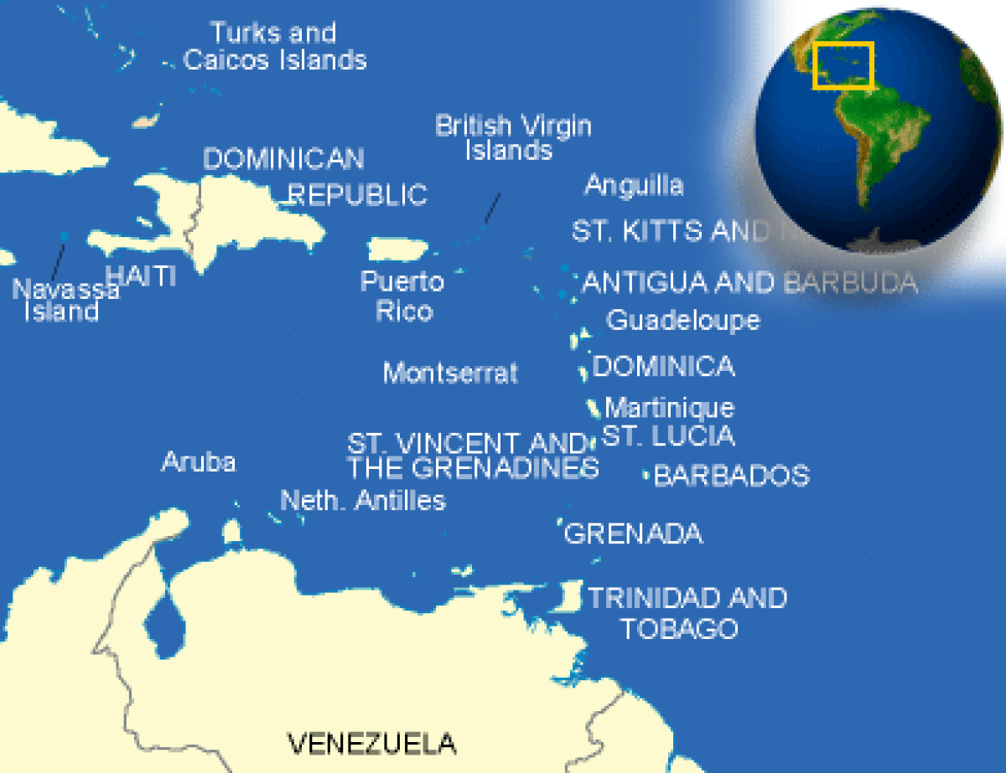

Aruba Geography
Geography - note
a flat, riverless island renowned for its white sand beaches; its tropical climate is moderated by constant trade winds from the Atlantic Ocean; the temperature is almost constant at about 27 degrees Celsius (81 degrees Fahrenheit)
Aruba Geography
Geographic Location | The Caribbean
Total Area | 69 Square Miles  180 Square Kilometers
Land Area | 69 Square Miles  180 Square Kilometers
Coastline | 43 Miles  69 Kilometers
Geographic Coordinates | 12 30 N, 69 58 W
Terrain | flat with a few hills; scant vegetation
Highest Point | 188 Meters
Highest Point Location | Mount Jamanota 188 m
Lowest Point Location | Caribbean Sea 0 m
Natural Resources | NEGL; white sandy beaches
Time Zone | UTC-4 (1 hour ahead of Washington, DC during Standard Time)

Aruba Weather and Climate
Climate and Weather
tropical marine; little seasonal temperature variation
Aruba Environmental Issues
Climate | tropical marine; little seasonal temperature variation
Terrain | flat with a few hills; scant vegetation
Natural Resources | NEGL; white sandy beaches
Natural Hazards | lies outside the Caribbean hurricane belt
Environmental Issues | NA

Aruba Population Details
Population | 109,153
Population Growth Rate | 1.39%
Urban Population | 46.8%
Population in Major Urban Areas | ORANJESTAD (capital) 37,000
Nationality Noun | Aruban(s)
Nationality Adjective | Aruban; Dutch
Ethnic Groups | mixed white/Caribbean Amerindian 80%
Languages | Dutch (official), Papiamento (a Spanish, Portuguese, Dutch, English dialect), English (widely spoken), Spanish
Population - note | Estimate based on a revision of the base population, fertility, and mortality numbers, as well as a revision of 1985-99 migration estimates from outmigration to inmigration, which is assumed to continue into the future; the new results are consistent with the 2000 census
Rate of Urbanization- annual rate of change | 0.54%

Aruba Medical Information
Medical care is generally considered to be good on Aruba. There is one hospital, Dr. H.E. Oduber Hospital, whose medical standards can be favorably compared to a small hospital in the U.S. The hospital has tiered health care, and accommodations will vary depending on insurance and the ability to pay. There is a small medical center in San Nicolas. Please be aware that there is no decompression chamber available on the island. We urge caution for scuba divers, since persons suffering from decompression sickness have to be medically evacuated for proper treatment. The many drug stores, or “boticas”, provide prescription and over the counter medicine. Visitors will need a local prescription, and may not be able to find medications available in the United States. Emergency services are usually quick to respond. Aruba is only about 14 degrees from the equator, so the solar radiation is very strong. Sunscreen is recommended anytime you are outside during the day.
Aruba Health Information
Death Rate/1,000 population | 8
Infant Mortality Rate/1,000 population | 12.12
Infant Mortality Rate- Female/1,000 population | 8.2
Infant Mortality Rate- Male/1,000 population | 15.97
Total Fertility Rate | 1.84
Drinking Water Source: unimproved | 2.2%
Drinking Water Source - percent of rural population improved | 97.8%
Drinking Water Source - percent of urban population improved | 97.8%
Sanitation Facility Access: unimproved | 2.3%
Sanitation Facility Access - percent of urban population improved | 97.7%
Sanitation Facitlity Access - percent of rural population improved | 97.7%

Aruba Crime
Crime Information
The crime threat in Aruba is generally considered low, although travelers should always take precautions when in unfamiliar surroundings. There have been incidents of theft from hotel rooms and vehicles. Armed robberies have been known to occur. Valuables left unattended on beaches, in cars and in hotel lobbies are easy targets for theft. Jewelry, phones, cameras and other electronics are the most commonly stolen items. Be especially observant when visiting isolated areas.
Car theft, especially of rental vehicles for joy riding and stripping, can occur. Vehicle leases or rentals may not be fully covered by local insurance when a vehicle is stolen or damaged. Be sure you are sufficiently insured when renting vehicles, jet skis, and other items.
We recommend that visitors take additional precautions when visiting the entertainment district of San Nicolas. Due to the popularity of this area with tourists, many petty crimes are reported in this area.
Parents of young travelers should be aware that the legal drinking age of 18 is not always enforced in Aruba, so extra parental supervision may be appropriate. Young travelers in particular are urged to take the same precautions they would when going out in the United States, e.g. to travel in pairs or in groups if they choose to frequent Aruba’s nightclubs and bars, and if they opt to consume alcohol, to do so responsibly. Anyone who is a victim of a crime should make a report to Aruban police, as well as report it immediately to the U.S. Consulate General on Curacao. Do not rely on hotel/restaurant/tour company management to make the report for you.
Don’t buy counterfeit and pirated goods, even if they are widely available. Not only are the bootlegs illegal in the United States, if you purchase them you may also be breaking local law.

Aruba Life Expectancy
Life Expectancy At Birth | 76 Years
Life Expectancy At Birth- Female | 79 Years
Life Expectancy At Birth- Male | 73 Years
Median Age (female) | 40 Years
Median Age (male) | 36 Years
Median Age | 38 Years

Aruba Literacy
Predominant Language | Dutch (official), Papiamento (a Spanish, Portuguese, Dutch, English dialect), English (widely spoken), Spanish
Literacy Definition | definition:
Literacy Total | 97.3%

Aruba Education
Education Expenditures - percent of GDP | 6%
Literacy - total population | 97.3%
Literacy Definition | definition:
School Life Expectancy - female | 14 Years
School Life Expectancy - male | 13 Years
Total School Life Expectancy - (primary to tertiary)

Aruba Government
Capital Name | Oranjestad
Country Name | Aruba
Full Country Name | none
Government Type | parliamentary democracy
Capital - geographic coordinate | 12 31 N, 70 02 W
Capital Time Difference | UTC-4 (1 hour ahead of Washington, DC during Standard Time)
National Holiday | Flag Day, 18 March (1976)
Constitution | 1 January 1986
Legal System | civil law system based on the Dutch civil code
Suffrage | 18 years of age; universal

Aruba Government and Politics
Government Executive Branch | chief of state: King WILLEM-ALEXANDER of the Netherlands (since 30 April 2013); represented by Governor General Fredis REFUNJOL (since 11 May 2004)  head of government: Prime Minister Michiel "Mike" Godfried EMAN (since 30 October 2009)  cabinet: Council of Ministers elected by the Staten  elections: the monarchy is hereditary; governor general appointed for a six-year term by the monarch; prime minister and deputy prime minister elected by the Staten for four-year terms; election last held on 25 September 2009 (next to be held by September 2013)  election results: Michiel "Mike" Godfried EMAN elected prime minister; percent of legislative vote - NA
Legislative Branch | unicameral Legislature or Staten (21 seats; members elected by direct popular vote to serve four-year terms)  elections: last held on 25 September 2009 (next to be held in 2013)  election results: percent of vote by party - AVP 48%, MEP 35.9%, PDR 5.7%, other 10.4%; seats by party - AVP 12, MEP 8, PDR 1
Judicial Branch | Common Court of Justice, Joint High Court of Justice (judges appointed by the monarch)
Regions or States | none (part of the Kingdom of the Netherlands)
Political Parties and Leaders | Aliansa/Aruban Social Movement or MSA [Robert WEVER]; Aruban Liberal Organization or OLA [Glenbert CROES]; Aruban Patriotic Movement or MPA [Monica ARENDS-KOCK]; Aruban Patriotic Party or PPA [Benny NISBET]; Aruban People's Party or AVP [Mike EMAN]; People's Electoral Movement Party or MEP [Nelson O. ODUBER]; Real Democracy or PDR [Andin BIKKER]; RED [Rudy LAMPE]; Workers Political Platform or PTT [Gregorio WOLFF]
International Organization Participation | Caricom (observer), FATF, ILO, IMF, Interpol, IOC, ITUC, UNESCO (associate), UNWTO (associate), UPU
Politicial Pressure Groups and Leaders | other: environmental groups
Diplomatic Representation in the US | none (represented by the Kingdom of the Netherlands); note - Mr. Henry BAARH, Minister Plenipotentiary for Aruba at the Embassy of the Kingdom of the Netherlands
Diplomatic Representation from US | the US does not have an embassy in Aruba; the Consul General to Curacao is accredited to Aruba

Aruba Economy Data
GDP - Gross Domestic Product | $2,516,000,000 (USD)
GDP - official exchange rate | $2,516,000,000 (USD)
GDP - real growth rate | 2.4%
GDP Per Capita | $25,300.00 (USD)
GDP by Sector- agriculture | 0.4%
GDP by Sector- Industry | 33.3%
GDP by Sector- services | 66.3%
Inflation Rate | 3.4%
Labor Force | 41,500
Labor Force by Occupation - note | most employment is in wholesale and retail trade, followed by hotels and restaurants
Unemployment Rate | 6.9%
Fiscal Year | calendar year
Annual Budget | $507,900,000 (USD)
Budget Surplus or Deficit - percent of GDP | -7.5%
Taxes and other revenues - percent of GDP | 24.8%
Major Industries | tourism, transshipment facilities, oil refining
Agriculture Products | aloes; livestock; fish
Currency Code | Aruban guilder/florin (AWG)
Commercial Bank Prime Lending Rate | 10.5%
Aruba Economy
Economic Overview
Tourism is the mainstay of the small, open Aruban economy, with offshore banking and oil refining and storage also important. The rapid growth of the tourism sector over the last decade has resulted in a substantial expansion of other activities. Construction has boomed, with hotel capacity five times the 1985 level. In addition, the reopening of the country's oil refinery in 1993, a major source of employment and foreign exchange earnings, has further spurred growth. Aruba's small labor force and low unemployment rate have led to a large number of unfilled job vacancies, despite sharp rises in wage rates in recent years. Tourist arrivals have declined in the aftermath of the 11 September 2001 terrorist attacks on the US. The government now must deal with a budget deficit and a negative trade balance

Aruba Exports
Exports | $124,000,000 (USD)
Major Exports | live animals and animal products, art and collectibles, machinery and electrical equipment, transport equipment
Top Export Partners | Netherlands 28.9%, Colombia 21.9%, Panama 17.2%, US 12.5%, Netherlands Antilles 8.6%, Venezuela 7.8%

Aruba Imports
Imports | $1,054,000,000 (USD)
Major Imports | machinery and electrical equipment, crude oil for refining and reexport, chemicals; foodstuffs
Top Import Partners | US 54.6%, Netherlands 12.7%, UK 5.7%

Aruba Flag
In March 1976, at the suggestion of the Flag Research Institute in Winchester, Mass., I went to Aruba to review the 700 plus designs that had been entered in a competition for a new island flag. I quickly learned that many Arubans wanted a distinctive flag that would represent their history and goals as they negotiated for a "status aparte" within the Netherlands Antilles.
A Flag Commission consisting of Julio Maduro, Epi Wever, and Roland Donk had met for months, going over colorful designs from the contest. They wanted no heraldic emblems, slogans, nor writing on the flag for such flags could not be read at a distance. It had to be inexpensive to manufacture, and "unlike any other flag, so it would be distinctive to Aruba." They rejected designs that did not meet their guidelines. They also wanted a design simple enough that a schoolchild could draw it, with colors contrasting well in order to be seen at a distance. Most importantly, they insisted that the flag, in its symbols and colors,
represent Arubans historically and culturally.
We found three designs that met their requirements. But Julio Maduro told me that the Island Council had already said those designs were not distinctive enough. On 6 March 1976, the Flag Committee decided had found two or three designs, which, with modifications, could represent Aruba. But, on my advice, the
Committee decided not to limit itself to those few designs. Instead, it chose to bring together designs and colors that Arubans who entered the contest had used, and to make a new flag with those. By taking ideas from the entire competition, the flag would represent more than the ideas and inspirations of
one contestant, and would reflect symbolically the feelings of most Arubans.
Symbols in the competition were often discs, stars, and stripes that were said to represent the sun, which was usually yellow or gold, but sometimes red. The sun's central position in Aruba's way of life and economy meant the health and happiness of all Arubans in a comfortable, benign climate. The sun also represented economic growth and national unity. Julio Maduro and Epi Wever told me that more than 50 nationalities live
in Aruba in tranquility admired throughout the world.
Stripes were found in more than half of the entries. Some were simple tricolor flags recalling 19th-century European democracies. Others were narrow bands dividing fields of color in more modern color combinations, often involving blue and yellow.
Another frequent symbol was a star. Stars represented the island itself, as well as liberty, unity or rebirth. But many of the stars were not the traditional five-pointed, but a bold four-pointed version. I told the commission that these special four-pointed stars were unlike any star found on any national flag. Julio and Epi said children often drew Christmas stars this way.
Deciding that the Aruban flag ought to feature some combination of stars, stripes, or discs, the Commission examined the colors they found in the contest. Blue, the most popular color, represented the Aruban sky or the Caribbean Sea, in shades from aquamarine to dark blue. The other popular color was yellow, nearly always said to represent sunlight. White symbolized Aruba's unique beaches, while red stood for sunset, the island's clay soil, progress, or the blood of Arubans.
The flag contest demonstrated that Arubans feel their country is unique in the world and in the Caribbean, that it enjoys an immutably beautiful sea and sunlight, and that many nationalities live in harmony. Aruba is a proud country, these flags declared, economically stable because of tourism and industry.
I felt that the background color had to be blue, ideally the vivid bright blue of the sea. Because Aruba is a peaceful Mecca for people around the world, the bright blue of the United Nations flag was an ideal match. Out of the blue field, a star rises in that corner, the canton, that is highest and nearest the hoist. Placing the star there meant it would be seen even when the flag is moving in the breeze. The star has, as many Arubans wanted, four points. Suggesting a compass, its four points represent North, South, East, and West, acknowledging that Arubans came from many nations in order to live in unity and strength.
The star is red because much of the soil of Aruba is red, but it is bordered in white to suggest the waves beating on its white beaches. The red soil of the interior ends with white beaches before the blue sea -- a symbol of the island itself. And the star refers also to the island's unity, diversity, vigor, and beauty.
The Commission pointed out that the four points also represented the four major languages: Papiamento, Spanish, English, and Dutch. And the red in the star reminded Julio Maduro of the Indians who once lived on the island, and of blood shed by Arubans during war. White was Aruba's honesty, while blue, the color of hope, represents its future and its ties to the past.
Finally, looking to the future, two narrow stripes were drawn across the blue field to suggest the movement toward "status aparte." Those stripes were very narrow because Aruba is apart, but not isolated as it embarks on its path. One stripe represents the flow of tourists to sun-drenched Aruba, enriching the island as well as vacationers. The second stripe is for industry, all the minerals (gold and phosphates in the past, petroleum in the early 20th century). The stripes announce a new, distinctive nationality with economic strength guaranteeing its independence, standing apart from the rest of the world, but working internationally.
The Flag Commission was happy with the flag that it had put together, but we had to find seven variations to give the Island Council a choice. We made four designs similar to the first one, but in fewer colors, some with white and blue only, others white, blue and yellow. And the original three designs that the Commission had chosen were added as well.
Betico Croes asked me to stay for another week until the Island Council selected the flag of Aruba so I could answer questions about the design. After they voted for the first design, I helped arrange to have the first flags manufactured in the United States. They were ready in time for hoisting for the first time on 18 March 1976.
The flag was consistent with the Flag Commission's guidelines. The design is simple but unlike any other flag it is the only flag with a four-pointed star. It is visible at a great distance and looks good flying in the ceaseless wind of Aruba or outstretched against a wall. Its elements are large and well placed, and its colors contrast well. It is easily drawn and inexpensive to manufacture. Every color, the star, the stripes, and placements of elements are symbolic of this island. No other country could be
represented by a white-bordered, four-pointed red star, and anyone who knows its symbolism will remember well the flag of Aruba.
Aruba flag
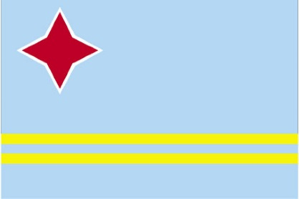

Anthem History | The Dutch anthem "Wilhelmous van Nassowe" is the official anthem of this Dutch colony, however a local anthem, a waltz, has been unofficially adopted as well, and is in use in the island.
Anthem Lyrics English | Aruba beloved home  our venerated cradle  though small and simple you may be  you are indeed esteemed.  Refrain:  Aruba our dear country  our rock so well beloved  our love for you is so strong  that nothing can destroy it. (repeat)  Your beaches so much admired  with palm trees all adorned  your coat of arms and flag  the symbols of our pride.  Refrain  The greatness of our people  is their great cordiality  and may God guide and preserve  its love for freedom.  Refrain
Aruba National Anthem History
The History of the Aruba National Anthem
The Dutch anthem "Wilhelmous van Nassowe" is the official anthem of this Dutch colony, however a local anthem, a waltz, has been unofficially adopted as well, and is in use in the island.

Aruba Interesting Facts
- Children take a treat to school for their classmates and all teachers. Each teacher receives a treat and gives the birthday child a small gift like a pencil, an eraser or a postcard. The birthday child is also allowed to wear special clothes instead of the school uniform.
- As far as can be concluded from historical records, the first European to set foot on Aruba was Alonso de Ojeda. This Spanish explorer landed on the Island in 1499. One of his first observations was that the remains he found belonging to the first settlers were considered to be larger than the average European of that day. He remarked that he had come to "an Island of giants".

History of Aruba
Aruba’s first inhabitants were the Caquetios Indians from the Arawak tribe. Fragments of the earliest known Indian settlements date back to about 1000 A.D. Spanish explorer Alonso de Ojeda is regarded as the first European to arrive in about 1499. The Spanish garrison on Aruba dwindled following the Dutch capture of nearby Bonaire and Curacao in 1634. The Dutch occupied Aruba shortly thereafter, and retained control for nearly two centuries. In 1805, during the Napoleonic wars, the English briefly took control over the island, but it was returned to Dutch control in 1816. A 19th-century gold rush was followed by prosperity brought on by the opening in 1924 of an oil refinery. The last decades of the 20th century saw a boom in the tourism industry. In 1986 Aruba seceded from the Netherlands Antilles and became a separate, autonomous member of the Kingdom of the Netherlands. Movement toward full independence was halted at Aruba’s prerogative in 1990. Aruba has a mixture of people from South America and Europe, the Far East, and other islands of the Caribbean

Aruba History Timeline
Aruba Year in History | Aruba Timeline
650 | First Arawak arrival
1499 | The Spanish discover the islands
1636 | Aruba is aquired by the Dutch
1805 | The island falls to the British  During the Napoleonic Wars.
1816 | Aruba is returned to the Netherlands  After coming under British rule during the Napoleonic Wars.
1824 | Gold is discovered near Bushiribana.
1863 | Slavery is abolished.
1924 | Aruba becomes home to one of the world's largest oil refineries
1929 | An oil refinery is established at San Nicolaas.
1954 | Aruba becomes part of the autonomous federation of the Netherlands Antilles.
1985 | Refineries are closed.  With refinery closures due to the worldwide glut in petroleum, tourism becomes especially important to the Aruban economy.
1986 | Island obtains autonomous status  Within the Kingdom of the Netherlands.
1991 | Oil refining is resumed

Aruba Holidays and Events
Display Date | Title
March 18 | Flag Day

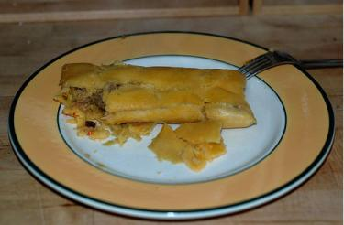

Aruba Languages
Languages
Dutch (official), Papiamento (a Spanish, Portuguese, Dutch, English dialect), English (widely spoken), Spanish
Language Translations:
Greetings in Dutch
Do you speak English? | Spreek jij Engels?
Excuse me | Excuseer mij
Fine / Good | Goed
Good afternoon | Goedenmiddag
Good evening | Goedenavond
Good morning | Goedenmorgen
Good night | Goedenacht
Goodbye | Tot ziens
Happy New Year! | Gelukkig Nieuwjaar!
How are you? | Hoe gaat het met jou?
I'm pleased to meet you | Aangenaam kennis met je te maken
Merry Christmas | Vrolijk Kerstfeest
Please | Alstublieft
See you later | Tot ziens
Thank you | Dank je wel
Welcome | Welkom
Yes / No | Ja / Nee
Hello | Hallo
Days in Dutch
Sunday | Zondag
Monday | Maandag
Tuesday | Dinsdag
Wednesday | Woensdag
Thursday | Donderdag
Friday | Vrijdag
Saturday | Zaterdag
Months in Dutch
January | Januari
February | Februari
March | Maart
April | April
May | Mei
June | Juni
August | Augustus
July | Juli
September | September
October | Oktober
November | November
December | December
Colors in Dutch
White | Wit
Black | Zwart
Red | Rood
Green | Groen
Blue | Blauw
Yellow | Geel
Orange | Yellow
Pink | Roze
Purple | Paars
Numbers in Dutch
One | één
two | twee
three | drie
four | vier
five | vijf
six | zes
seven | zeven
eight | acht
nine | negen
ten | tien
eleven | elf
twelve | twaalf
thirtheen | dertien
Fourteen | veertien
Fifteen | vijftien
sixteen | zestien
seventeen | zeventien
eighteen | achttien
nineteen | negentien
twenty | twintig
twenty-one | eenentwintig
twenty-two | tweeëntwintig
twenty-three | drieëntwintig
twenty-four | vierentwintig
twenty-five | vijfentwintig
twenty-six | zesentwintig
twenty-seven | zevenentwintig
twenty-eight | achtentwintig
twenty-nine | negenentwintig
thirty | dertig
thirty-one | eenendertig
fifty | vijftig
one hundred | honderd
five hundred | vijfhonderd
one thousand | duizend
Seasons in Dutch
Winter | Winter
Fall | Herfst
Spring | Lente
Summer | Zomer
Greetings in Papiamento
A kiss | Un sunchi
Fine / Good | Bon,
Good afternoon | Bon tardi
Good evening | Bon tardi
Good night | Bon nochi
Goodbye | Ayo
Happy birthday | Masha pabien
Have a nice day | Pasa un bon dia
How are you? | Con ta bai?
Merry Christmas | Bon Pasku
See you later | Te aworo
Thank you | danki
very good | Hopi bon
Welcome | Bon bini
Days in Papiamento
Sunday | Diadomingo
Monday | Dialuna
Tuesday | Diamars
Wednesday | Diarazon
Thursday | Diahuebs
Friday | Diabierna
Saturday | Diasabra
Months in Papiamento
January | Januari
February | Februari
March | Maart
April | April
May | Mei
June | Juni
July | Juli
August | Augustus
September | September
October | October
November | November
December | December
Colors in Papiamento
Blue | blou
Green | berde
Pink | ros
Purple | lila
Red | cora
White | blancu
Yellow | geel
Numbers in Papiamento
one | un
two | dos
three | tres
four | cuatro
five | cinco
six | seis
seven | shete
eight | ocho
nine | nuebe
ten | djes
fifty | cincuenta
one hundred | shen
one thousand | mil
Greetings in Spanish
Do you speak English? | Habla usted ingles?
Do you speak Spanish? | Habla usted espanol?
Excuse me | Dispenseme
Fine / Good | Bien
Good afternoon | Buenas tardes
Good evening | Buenas tardes
Good morning | Buenos diás
Good night | Buenas noches
Goodbye | Adios
Happy New Year! | ¡Felíz año nuevo!
Hello | ¡Hóla!
How are you? | Como esta usted?
I'm pleased to meet you | Encantado de conocerle
Merry Christmas | Feliz Navidad
Please | Por favor
See you later | Hasta luego
Thank you | Gracias
Welcome | Bienvenido
What is your name? | Como se llama? / Deme su nombre
Yes / No | Si / No
Days in Spanish
Sunday | Domingo
Monday | Lunes
Tuesday | Martes
Wednesday | Miercoles
Thursday | Jueves
Friday | Viernes
Saturday | Sabado
Months in Spanish
January | Enero
February | Febrero
March | marzo
April | Abril
May | Mayo
June | Junio
July | Julio
August | Agosto
September | Septiembre
October | Octubre
November | Noviembre
December | Diciembre
Colors in Spanish
Black | Negro
Blue | Azul
Green | Verde
Orange | Anaranjado
Pink | Rosado
Red | Rojo
White | Blanco
Yellow | Amarillo
Numbers in Spanish
One | Uno
Two | Dos
Three | Tres
Four | Cuatro
Five | Cinco
Six | Seis
Seven | Siete
Eight | Ocho
Nine | Nueve
Ten | Diez
Fifty | Cincuenta
one Hundred | Cien
One Thousand | mil

